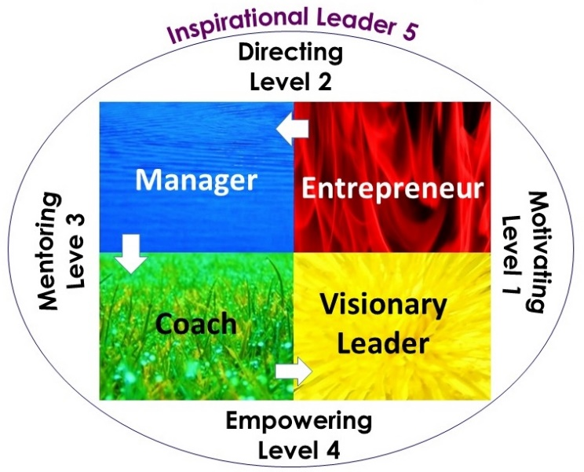
When I ask business owners the above question, they’ll often ask me what I mean. So I qualify the question with another one. I ask them:
“Could you go on holiday for four weeks, have no contact with your team whilst you’re away and know that the organisation can still thrive?”
Mostly the answer is a resounding “NO!”
There are styles of leadership based on the kind of personality that the leader is but those styles are also part a lifecycle. Sounds ambiguous I know, but if you’ve ever heard of the double slit experiment, you’ll know that a light particle can act both as a particle and as a wave. So it is with personality. It is both a snapshot of a person, when you care to look and also part of a continuous universal life cycle that goes on in the background.
Let’s take personalities and explain them in terms of leadership styles:
Entrepreneurial Leader: These are Driver personalities, they like to motivate and direct their team to get the job done. Shipping is more important than perfection and with a hands on attitude, they will take on challenges and fix problems on the go. They will use the force of their personality to drive for results and be very direct in their communication. But if Drivers sense that they are losing control of a situation, they can become stressed and this can spread to the team who will often feel pressured.
Managerial Leader: The Developer personality is concerned with pursuing excellence. They will have rules and processes to ensure that there is little room for error. Because they believe they’re the best people to get the job done correctly, they usually find themselves overworked. Of course when you disempower the team from solving their own problems, then you lower the team’s engagement levels. To fix this Managers will introduce more processes and rules to maintain discipline leading to more of what they don’t want.
Coaching Leader: The Facilitators of the team like to empower people to solve their own challenges. Their primary purpose is to promote the wellbeing of the team and strengthen relationships. They are great at earning people’s trust and getting others to open up in conversations. However; when the going gets tough and conflicts arise they may then withdraw from the conversation. The Coaching leader always want the team to solve problems themselves when in reality, sometimes the team are wanting the leader to step up and take control. Generally though, when handled appropriately, this is the level where you see high engagement and peak performance from the team.
Visionary Leader: A visionary leader prefers to be more independent from the team because they don’t like the team to lean too heavily on them. They’re big picture thinkers, creative and prefer the freedom to work in that realm. They will paint a colourful picture of what the perfect day looks like for the organisation and then will expect the team to go forth and achieve the dream. Some members of the team might prefer a bit more direction and detail, especially in the early stages of a project.
Inspirational Leader: This Inspirational leader wants the work to be meaningful. They could favour any personality but are purposeful, adaptable and self-aware. Inspirational leaders are concerned with making the world a better place. They will lean towards a certain leadership style based on their personality, but can adapt to other styles when the situation demands it. Their viewpoint shifts from being ego-centric to eco-centric.
When they start a new venture or take the position as leader of an existing one, they see the organisation as a system which has a life of its own. Like a parent that enables a child to individuate psychologically from themselves so that the child can fulfil its potential, an inspirational leader will empower the team to be able to unleash theirs.

The Transfer of Power
So when we look at leadership in terms of a life cycle, we see levels that lead to a transfer of power from the leader to the team. Once this has happened the Leader stops ‘carrying’ the business and begins using a more ‘influencing’ style of leadership.
Level 1: Initially leadership has to motivate the team. Both leader and the small start-up team have to muddle through and carve their own path to success.
Level 2: Once the leader and team have secured some measure of success, the leader will want to bring in some rules and regulations. This directs the team to operate in a certain way and provides some security.
Level 3: The leader then takes on a mentoring role. The leader has a foot in the past by way of sharing experience and best practice. With the other foot in the future by beginning to coach future leaders. The team are encouraged to experiment with new ideas once they’ve displayed sufficient proficiency.
Level 4: The leader at this stage is fully committed to empowering the organisation and teams to unleash their full potential so they can achieve the vision for the organisation. It is a more hands off approach supported by high performance teams and a coaching culture.
Level 5: At this stage the Leader is purpose driven and can begin to look at other projects and opportunities. At this level the organisation could begin to change direction by letting some products and services, which are no longer viable, be killed off. This creative destruction allows other people to begin new product lines and services which can run separately, but be supported by the parent organisation.
Richard Branson is a good example of the inspirational leader, who has created many businesses under the one brand. The diversity of his Virgin empire and his collaborative partnerships ensures business resilience.

Know yourself and Know the Paradigm You’re in
To master the leadership journey, it is really a case of understanding who you are, what your strengths and weaknesses are and know where you are on the journey. The Inspirational Leader influences the direction of the organisation as opposed to trying to carry and control the business. Much like floating in a hot air balloon. You can influence the balloon by gaining or losing height, waiting for the right conditions to move, but you can’t really control the wind. Does anybody really control the economy?
Obviously if one really wanted to remain in control, you could try to carry the balloon towards your given destination. Or you could play the universe at its own game by going with the flow and being open to what is. One philosophy is a lot more satisfying for all concerned than the other. As Joseph Campbell advises:
“We must be willing to let go of the life we planned so as to have the life that is waiting for us.”

